 | Weekly Team Task Report | #8

Team: GeoLearn |  |  |  |  |  | Date: 3/9/2020
Project Title: Improving elementary education with custom online enironmental science lectures

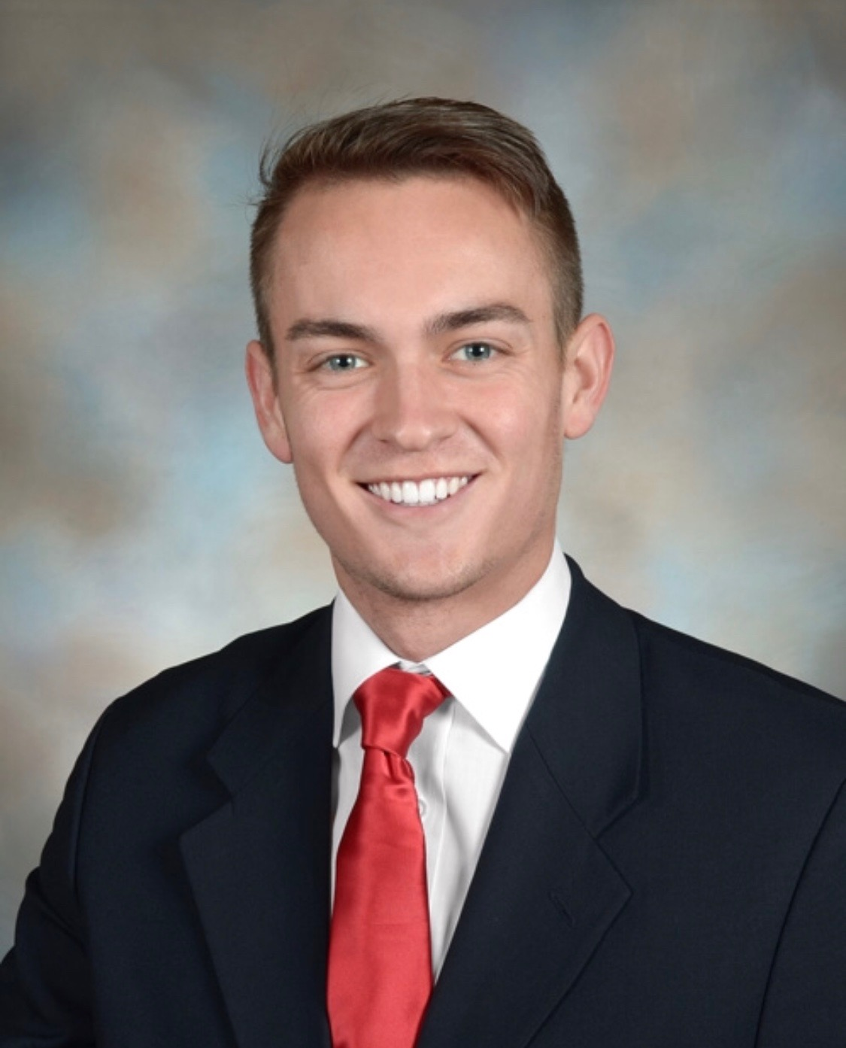 | Samuel Prassse  Present  On-time | 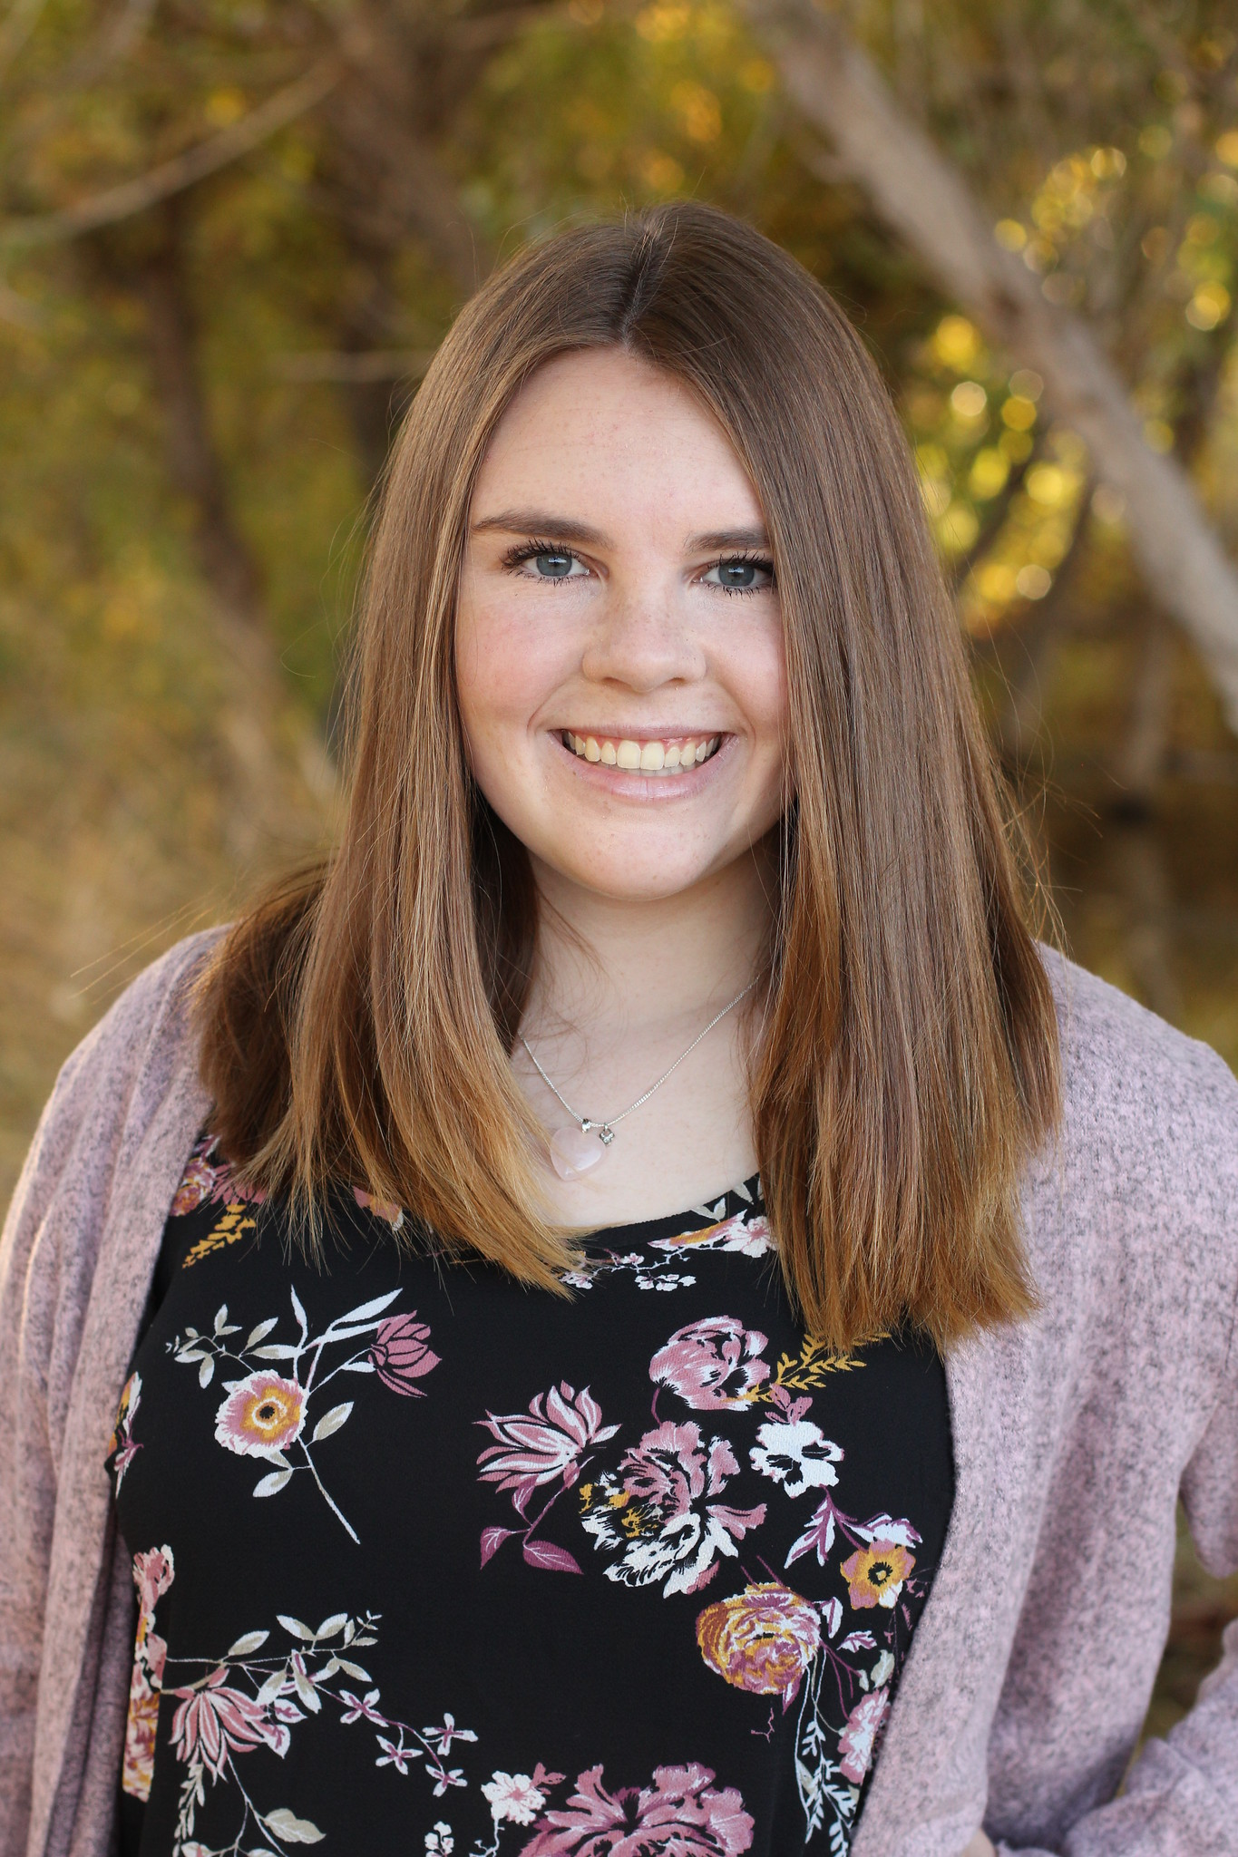 | Kaitlyn Grubb  Present  On-time | 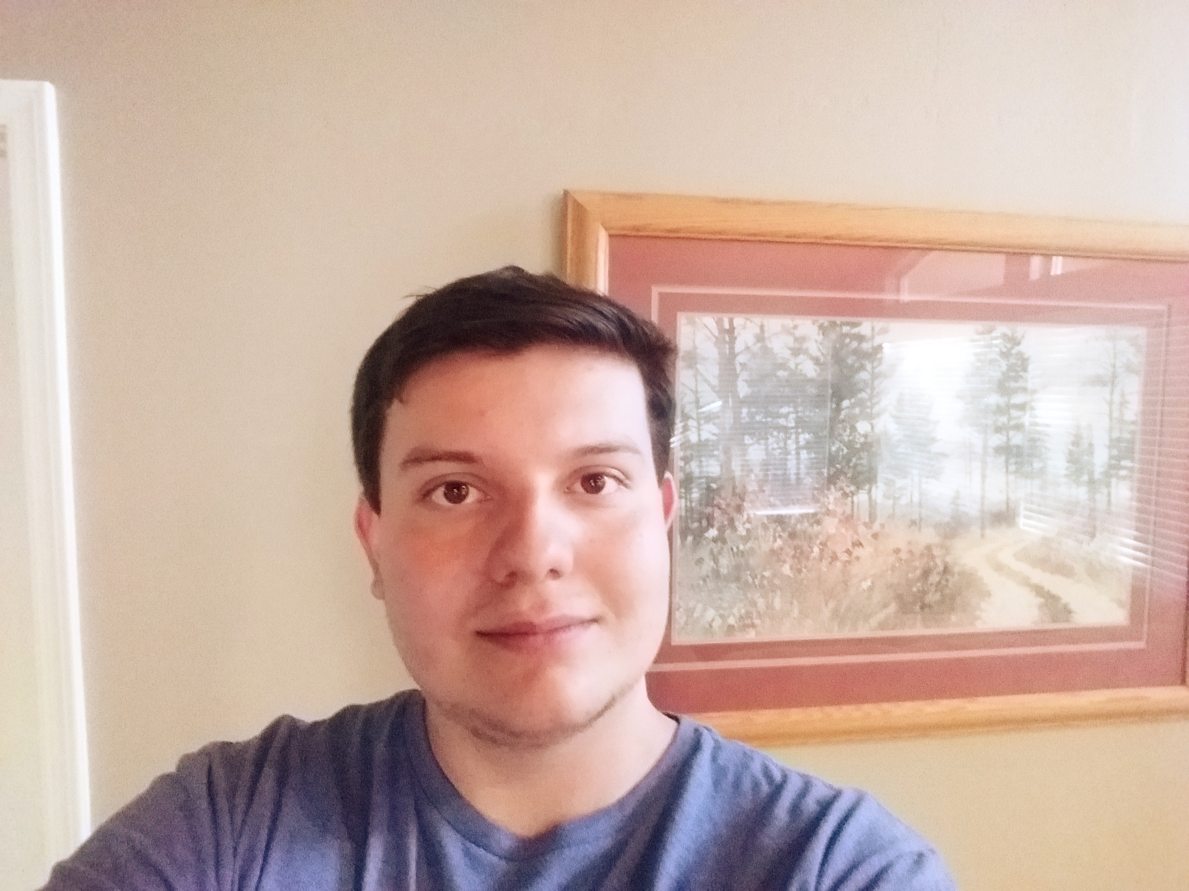 | Tyler Pehringer  Present  On-time |  | 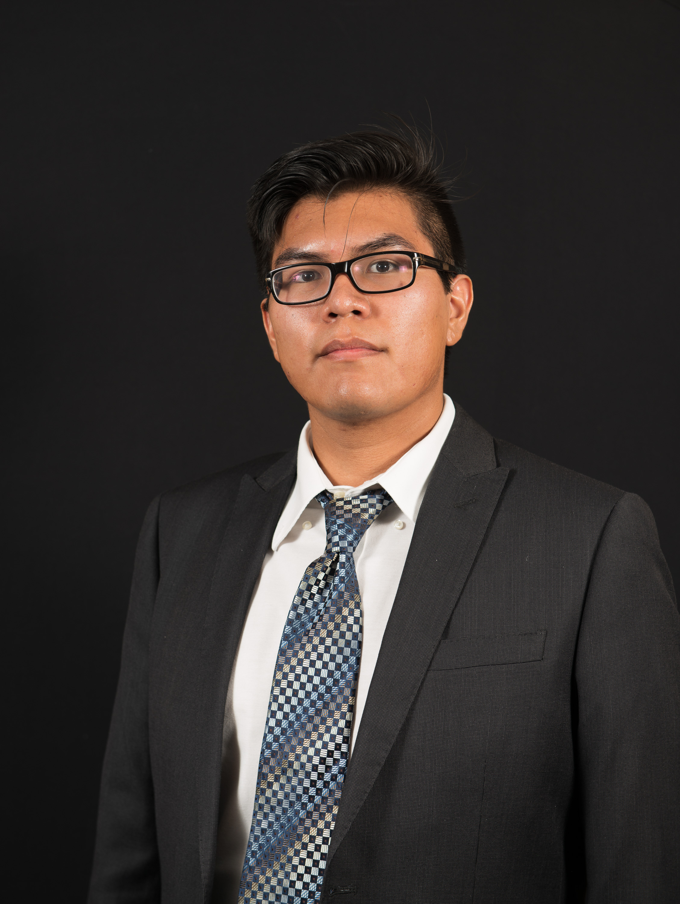 | Joshus Tenakhongva  Present  On-time

Recent Meetings:
- General Team Meeting
- Sponsor Meeting

TASKS COMPLETED since last meeting:

Task Title: Full Prototype Demo | Task Initiation: 3/3 | Orig. Due Date: 3/4 | Status: Completed
Who (%): Samuel (25%), Kaitlyn (25%), Tyler (25%), Joshus (25%)
Description: The team will demonstrate all implementation of all core functions of the product as a coherent solution satisfying all core use cases. We will schedule a meeting time with our mentor for the following week to demonstrate our product.
Expected Outcome: Full implementation of our Alpha prototype.

Task Title: Implement new slideshow templates | Task Initiation: 3/3 | Orig. Due Date: 3/13 | Status: Completed
Who (%): Samuel (25%), Kaitlyn (25%), Tyler (25%), Joshus (25%)
Description: The team will utilize the templates given to us by our sponsor and implement them into the website by creating a skeleton template for them and populating them with geospecific data.
Expected Outcome: Add land use change and climate change presentations to project.

Task Title: Continue website design | Task Initiation: 3/3 | Orig. Due Date: 3/13 | Status: In Progress
Who (%): Tyler (100%)
Description: Tyler will continue to develop the design of the website through meetings with Dr. Doughty and Roo.
Expected Outcome: A sleek website that conforms to the sponsor’s specifications.

This week’s Tasks: Work plan for coming week

Task Title: Continue website design | Task Initiation: 3/9 | Orig. Due Date: 3/16 | Status: In Progress
Who (%): Tyler (100%)
Description: Tyler will continue to develop the design of the website through meetings with Dr. Doughty and Roo.
Expected Outcome: A sleek website that conforms to the sponsor’s specifications.

Task Title: Pull more data from earth engine | Task Initiation: 3/9 | Orig. Due Date: 3/16 | Status: In Progress
Who (%): Samuel (75%), Joshus (25%)
Description: Samuel and Joshus will work on gathering more data from earth engine with the help of Dr, Doughty. He will be sending us certain code to implement into the slideshow presentations.
Expected Outcome: Complete the final two slideshow presentation templates.

Task Title: Peer Eval 2 | Task Initiation: 3/9 | Orig. Due Date: 3/13 | Status: In Progress
Who (%): Team (100%)
Description: Team will submit peer evals to Fabio by Friday the 13th.
Expected Outcome: Review the teammates relative to their performances over the past month.

Upcoming Tasks: Planning
Task Title: Software Testing Plan | Who (%): Team (100%) | Rough Due Date: 3/13
Description: Ensuring that our project's implementation exhibits the necessary functional and non-functional characteristics.

Other Problems / Other Issues:
- Correct Pictures

Github:
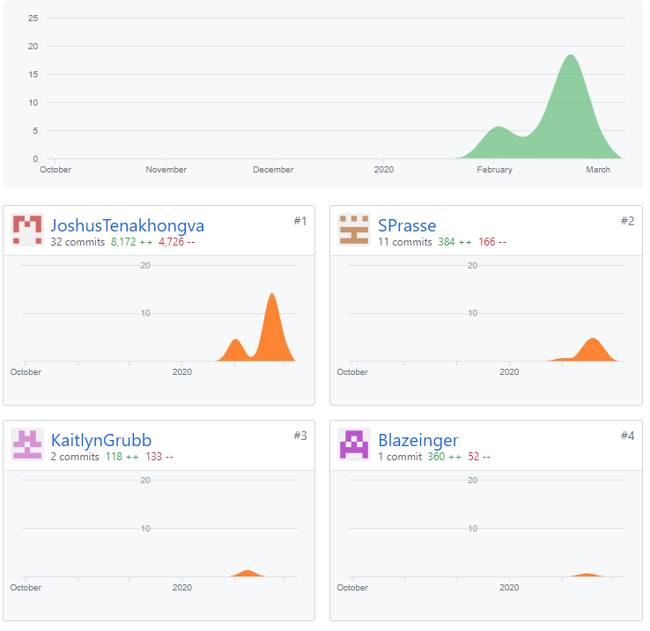

Schedule:

